Read the comparative essay by Brandon Chow, titled "Nuclear, Wind, and Solar," and then answer the following questions.

Nuclear, Wind, and Solar

In our world today, power is a regular demand we have in our daily lives. In this essay, I will look at two different power sources and compare them: wind & solar vs. nuclear. Both are extremely powerful sources but I will uncover which is more environmentally friendly in terms of reducing global warming and how they harm the environment.

Solar and wind power are extremely environmentally friendly, using only renewable resources as their source of power. Masson et al. (2014) state that "The production of solar energy in cities is clearly a way to diminish our dependency to fossil fuels, and is a good way to mitigate global warming by lowering the emission of greenhouse gases". As a developed nation, we tend to use an obscene amount of energy. The main reason these two sources are so environmentally friendly is because they reduce the release of carbon emissions in the atmosphere, which is the cause of global warming. According to Environment America Research & Policy (2014), "In 2013, wind power displaced more than 132 million metric tons of carbon dioxide".

Solar power uses sun rays to generate thermal energy, which powers whatever we need; and wind turbines use wind to set turbines into motion, which generate the power. Nuclear energy is very efficient at producing energy and reliable; however, it does release CO2 into our atmosphere, during the production of energy, which increases global warming. As stated by Skorodin (2010), a global researcher of global warming, "Once you release all that energy from uranium, as in a nuclear reactor, it is here forever, except for some fraction that radiates out into outer space as "longwave radiation." The rest goes into the air, waterways, glaciers, dirt and rocks as waste heat, also called thermal (heat) pollution, increasing the temperature, thereby bringing about global warming (Skorodin, 2010). Comparing both of these power sources together, solar and wind power are more environmentally friendly and reduce global warming, unlike nuclear power, which emits carbon dioxide causing global warming.

Nuclear energy is a reliable source; however, it carries risk, and accidents do occur. Japan is well known for its nuclear power plants and how much power they supply. In the year 2011 Fukushima Japan suffered a deadly earthquake that compromised its nuclear reactors. Starr (2012) states that the Japanese Science Ministry reported that long-lived radioactive cesium had contaminated 11,580 square miles (30,000 sq km) of the land surface of Japan'. The accident impacted the majority of the wildlife and the island of Japan itself. As stated by Starr, "Once a large amount of radioactive cesium enters an ecosystem, it quickly becomes ubiquitous, contaminating water, soil, plants and animals. It has been detected in a large range of Japanese foodstuffs, including spinach, tea leaves, milk, beef, and freshwater fish up to 200 miles from Fukushima" (Starr 2012).

On the other hand, solar and wind power also impact the environment in negative ways as well. Building the solar panels and wind turbines around the country, or wherever they need to be placed, is damaging to the local flora and fauna that rely on the ecosystem. For instance, wind turbines need a large amount of space for the wind to affect the propellers that power them. This means trees need to be removed, as well as plants, animals, homes, and rocks. Clear cutting forests also alters the ecosystem negatively in areas in which animals thrive. Solar panels also need to be built on high elevated areas to obtain the maximum amount of sun; accordingly, trees cannot block the sun from reaching the solar panels. Equally, birds' nests need to be moved for the installation of the panels. Considering these options, each has detrimental impacts on the environment; however I believe less environmental damage is caused by solar and wind power.

Each power source, nuclear, solar, and wind is very reliable for energy use. Solar and wind keep global warming minimal but in the process of installation could potentially harm the ecosystem in the process. Nuclear power may increase global warming somewhat but when natural disasters occur, it is highly likely that environmental damage will occur from the power plants. All in all both sources are very powerful but I would side with solar and wind power, due to the fact that it minimizes environmental damage and helps reduce carbon emissions, which reduces global warming.

Bibliography

1. http://energyrealityproject.com/lets-run-the-numbers-nuclear-energy-vs-wind-and-solar/

2. http://www.environmentamerica.org/reports/ame/more-wind-less-warming

3. http://www.globalresearch.ca/nuclear-energy-causes-global-warming/20231

4. http://journal.frontiersin.org/article/10.3389/fenvs.2014.00014/full

5. http://www.psr.org/environment-and-health/environmental-health-policy-institute/responses/costs-and-consequences-of-fukushima.html

6. http://www.ucsusa.org/clean-energy/renewable-energy/public-benefits-of-renewable-power#.WESOTqMZPRO

1) Citations and References.

Which of the following statements accurately describes the citations and references in this essay (which required APA formatting)?

A. The in-text citations generally follow APA formatting (except for one missing comma between an author's surname and the year), but the reference list does not.

B. The reference list follows APA style, but the in-text citations follow MLA style.

2) Paragraph 2. The writer states the following: "Solar and wind power are extremely environmentally friendly, using only renewable resources as their source of power. Masson et al. 2014) state that 'The production of solar energy in cities is clearly a way to diminish our dependency to fossil fuels, and is a good way to mitigate global warming by lowering the emission of greenhouse gases'."

The citation in the second sentence is introduced rather abruptly.

Which of the following phrases would add cohesion between the two sentences?

A. In this regard,

B. Therefore,

3) Paragraph 2. In the introduction, the writer does not offer any stance on the question of whether climate change is caused by human activity. In which of the following sentences of paragraph 2 does he effectively present his personal stance (that carbon emissions cause global warming)?

A. The main reason these two sources are so environmentally friendly is because they reduce the release of carbon emissions in the atmosphere, which is the cause of global warming

B. Masson et al. (2014) state that "The production of solar energy in cities is clearly a way to diminish our dependency to fossil fuels, and is a good way to mitigate global warming by lowering the emission of greenhouse gases".

4) Paragraph 4. The writer includes the following direct quotation: "Once a large amount of radioactive cesium enters an ecosystem, it quickly becomes ubiquitous, contaminating water, soil, plants and animals. It has been detected in a large range of Japanese foodstuffs, including spinach, tea leaves, milk, beef, and freshwater fish up to 200 miles from Fukushima" (Starr 2012)

Which of the following statements accurately describes the quotation?

A. The formatting is correct according to APA guidelines

B. The quotation is over 40 words and according to APA guidelines, it should be formatted as follows: drop a line, indent, remove quotation marks, and place the final period before the parentheses.

5) Paragraph 3. In the second sentence, the writer states the following: "Nuclear energy is very efficient at producing energy and reliable; however, it does release CO2 into our atmosphere, during the production of energy, which increases global warming."

Why did he write "however, it does release" instead of "however, it releases"?

A. The addition of the word does emphasizes the reliability of nuclear energy, mentioned in the first part of the sentence.

B. The addition of the word does effectively implies that other sources de emphasize the fact that nuclear energy releases CO2, perhaps to make it seem more environmentally friendly.

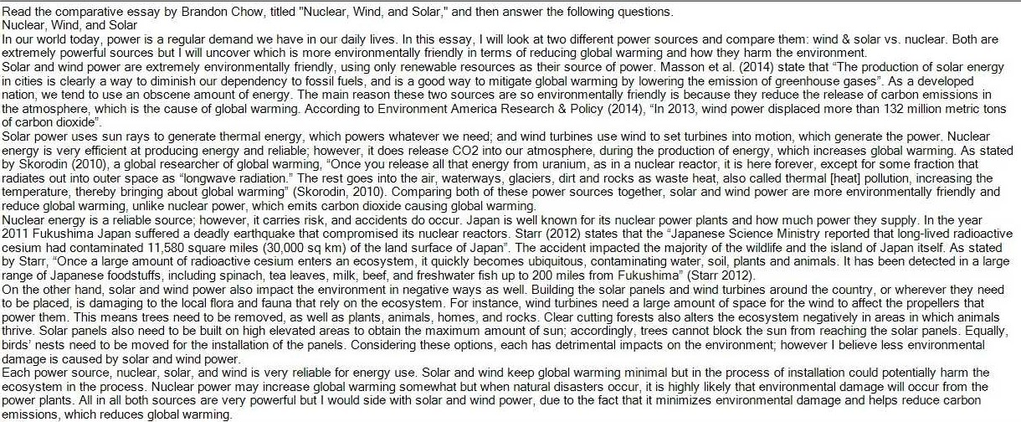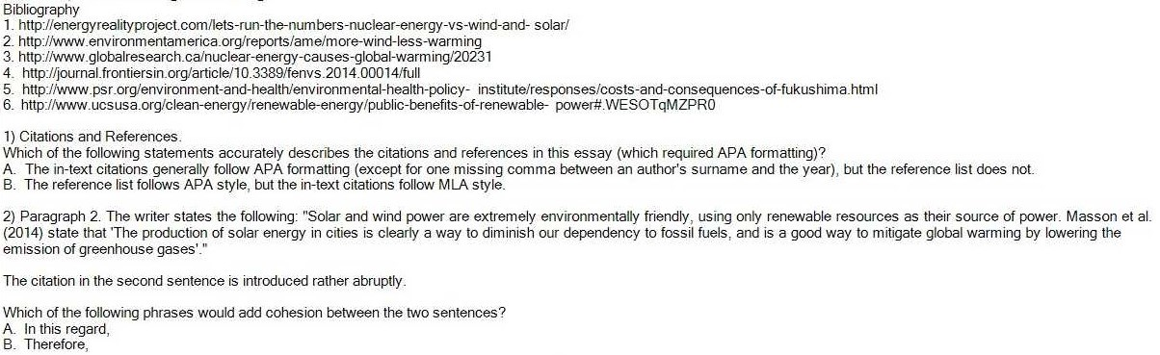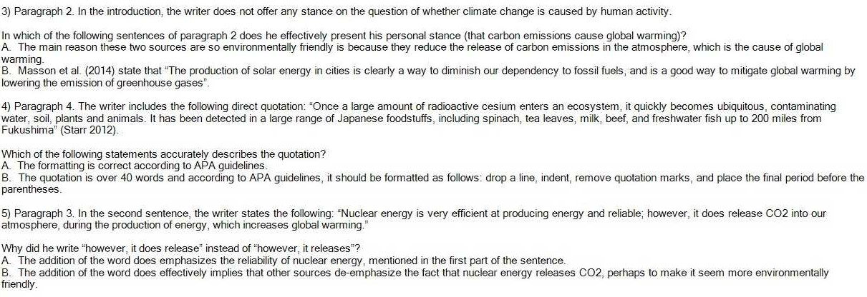

DAP AN

1A

2A

3A

4B

5B